# Test Case-1 SMMPRPFA: Rationalization (Region A) (Add CJ Input )

Initial Screen:

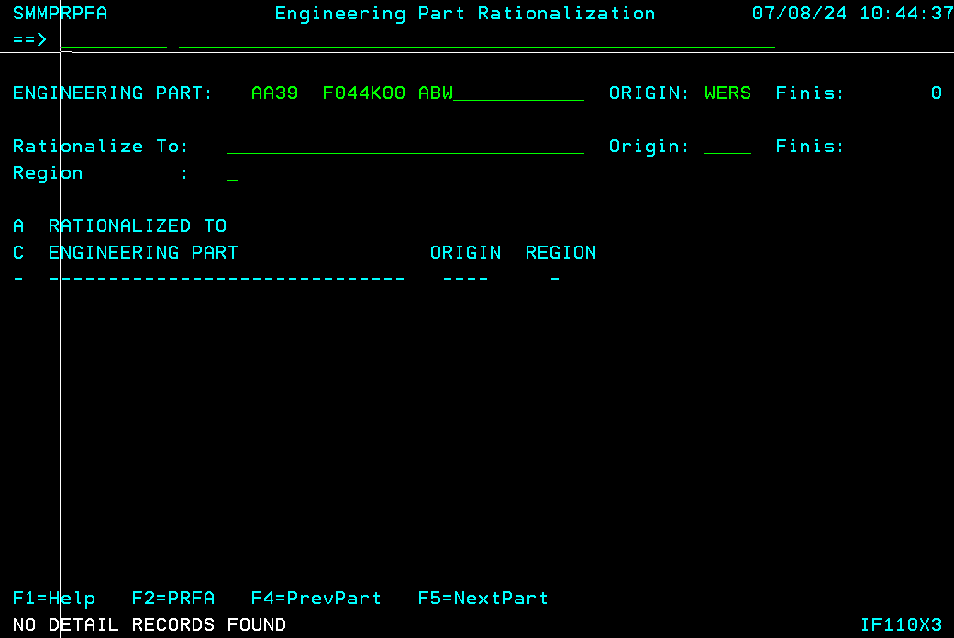

Rationalize (Action code: C)

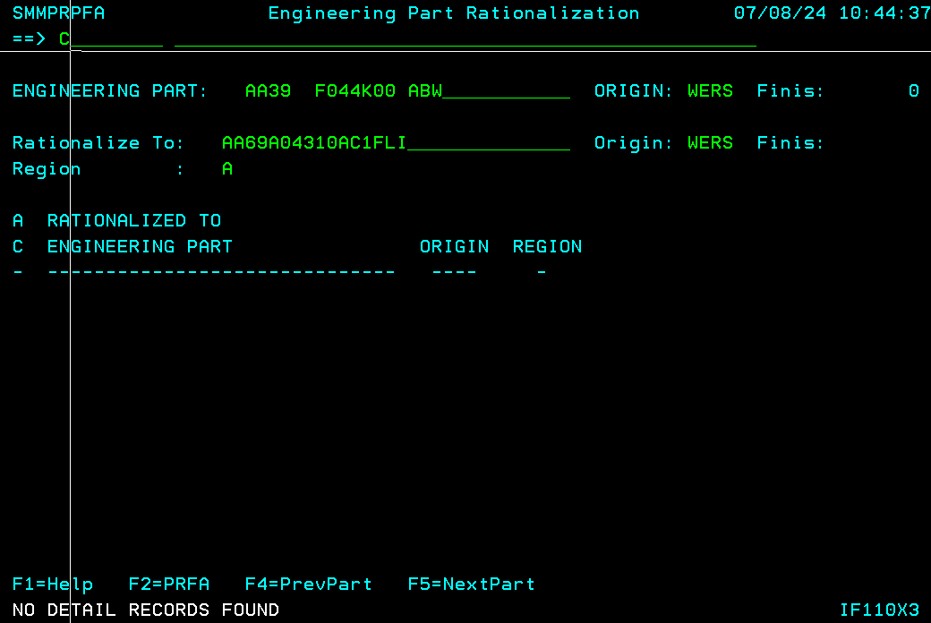

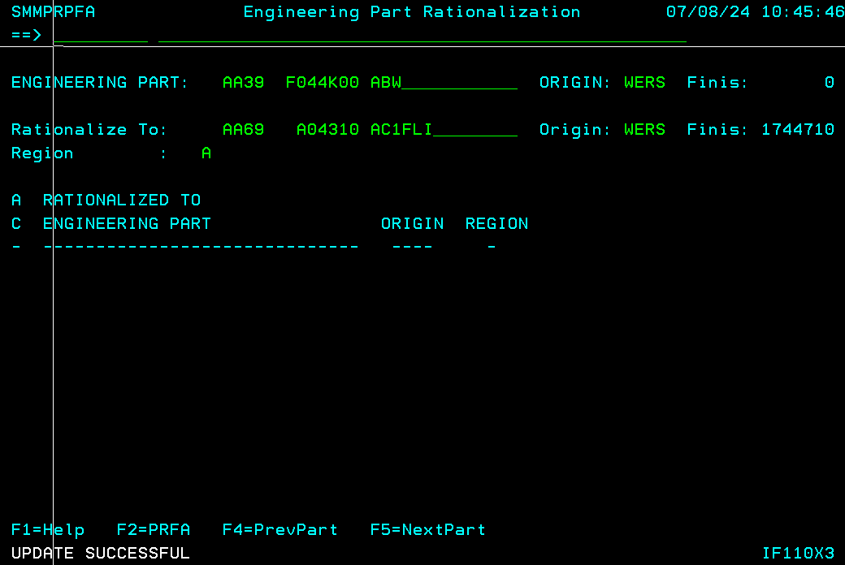

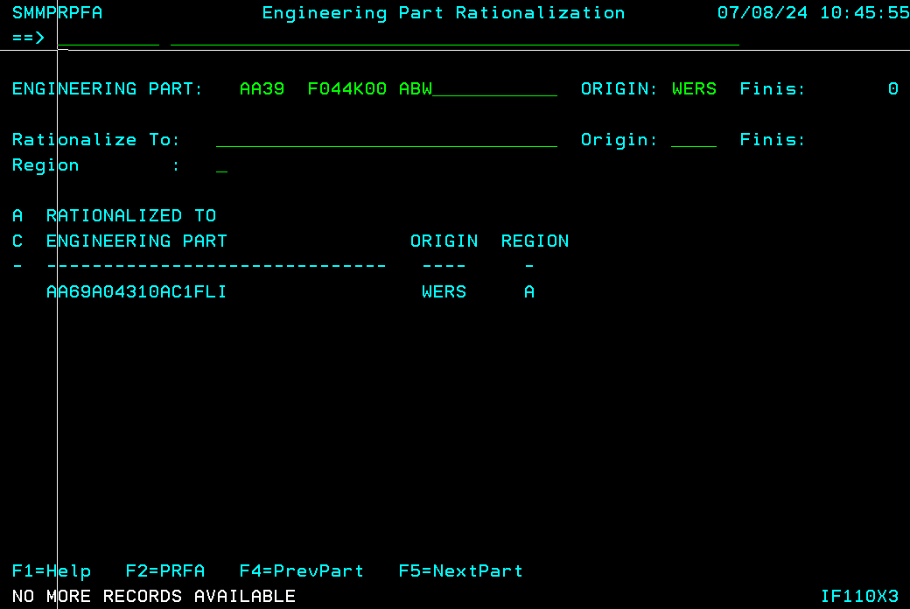

Old EPN Usages:

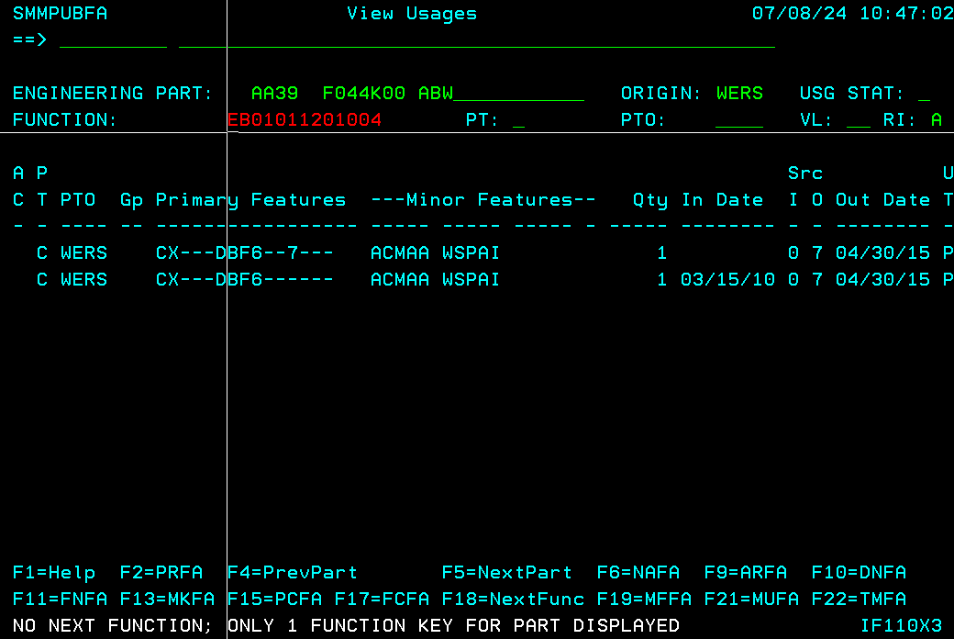

After Batch Job run: (New EPN has NUAD usage of old EPN usage)

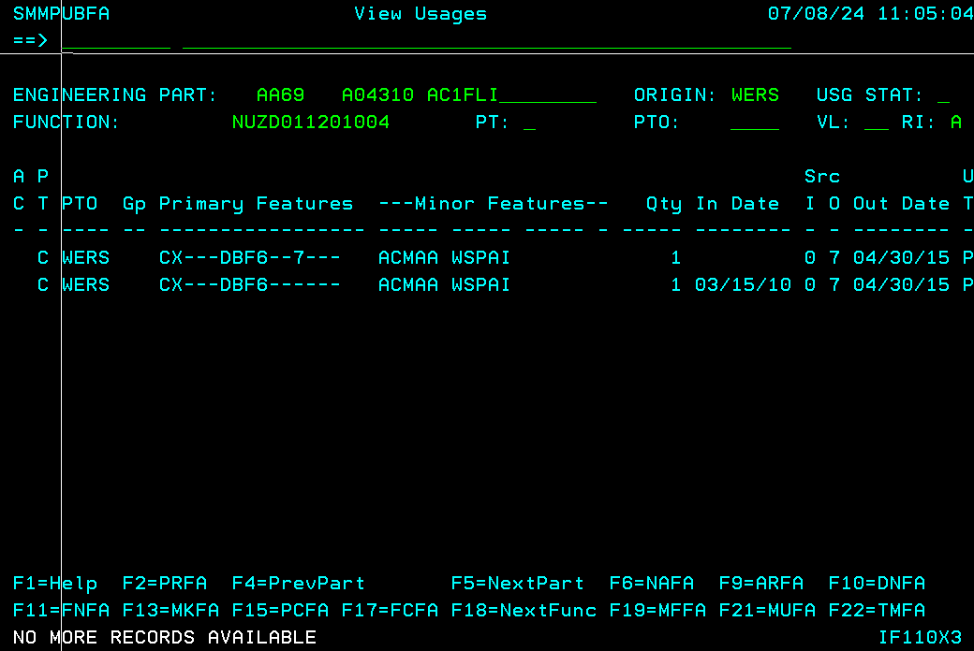

# Test Case-2 SMMPRPFA: De-rationalization (Region A) (Delete CJ Input )

Initial Screen:

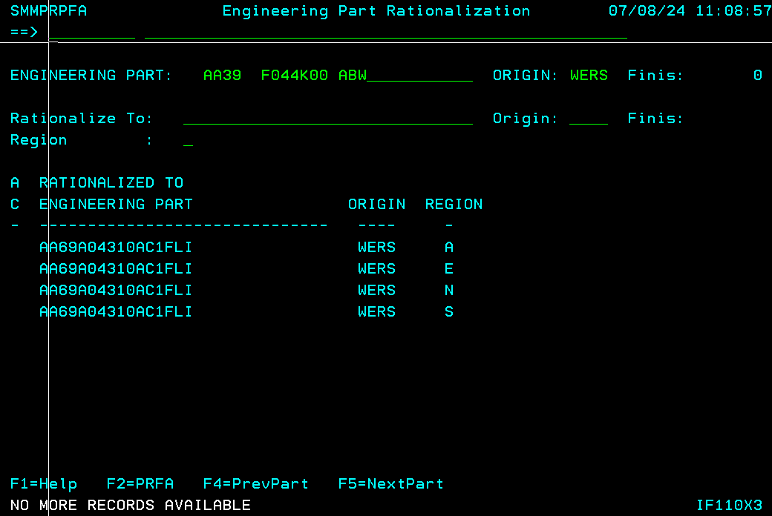

De-rationalize (Action code: D)

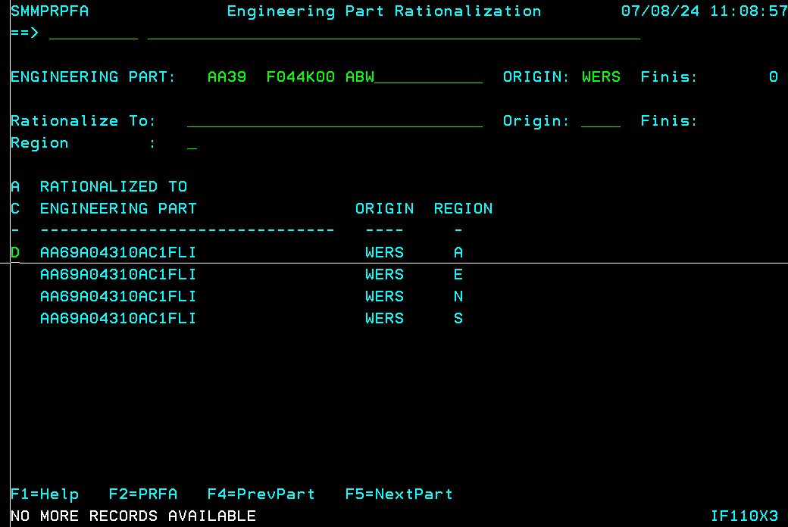

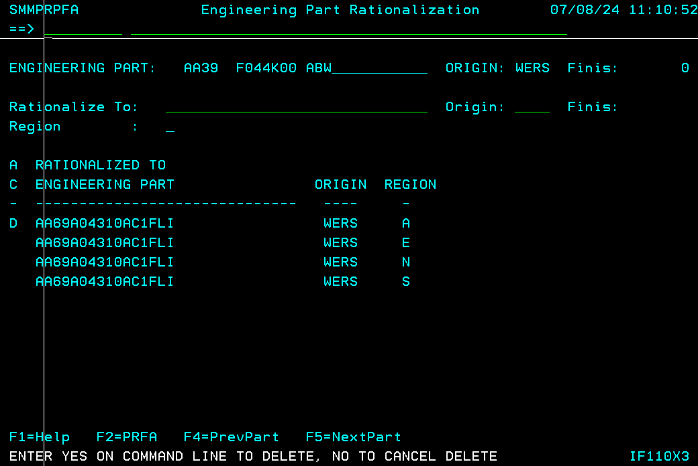

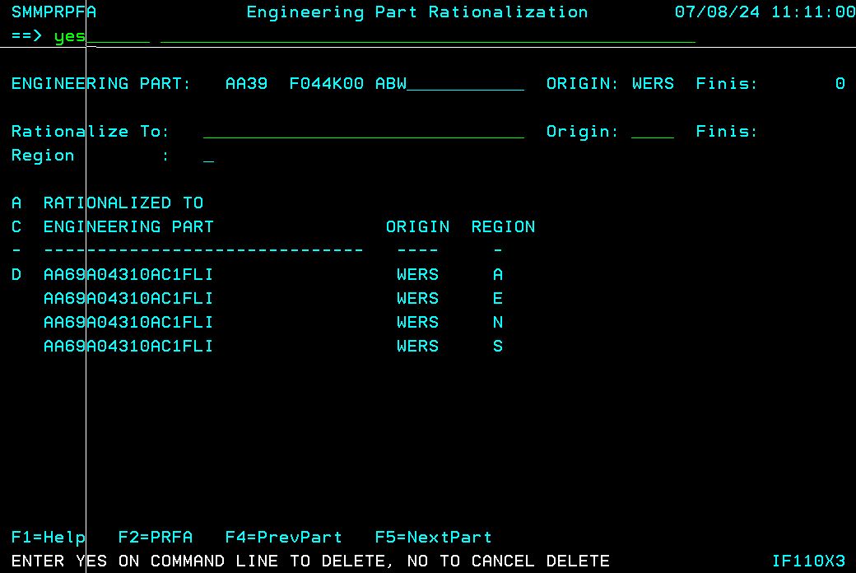

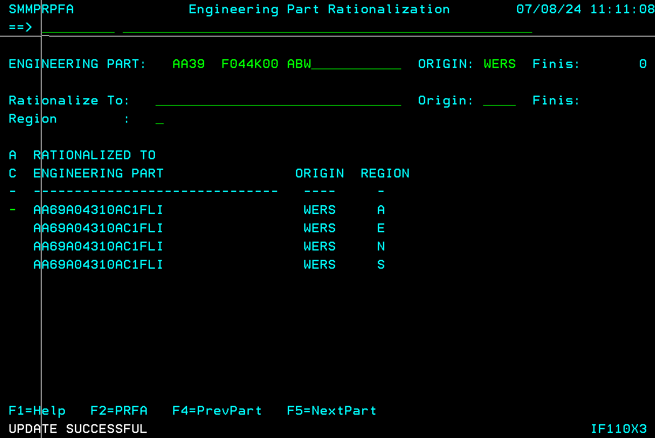

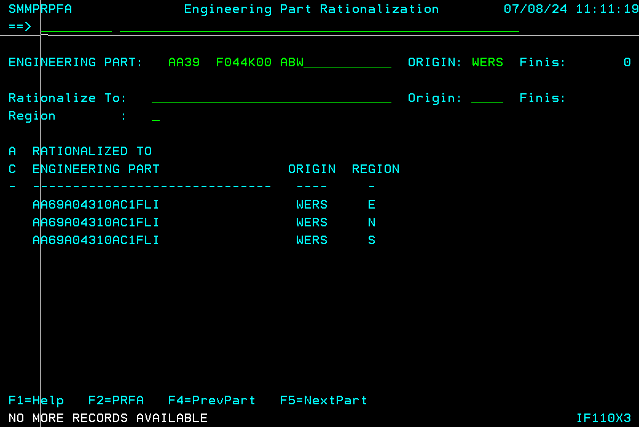

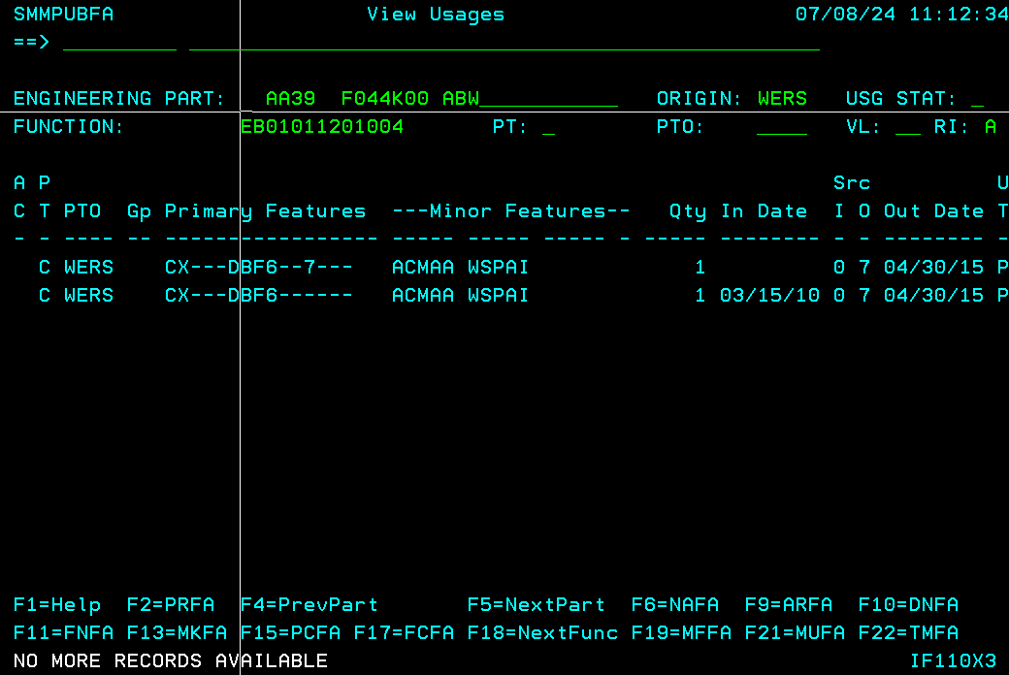

Active usages deleted and reinserted with N status:

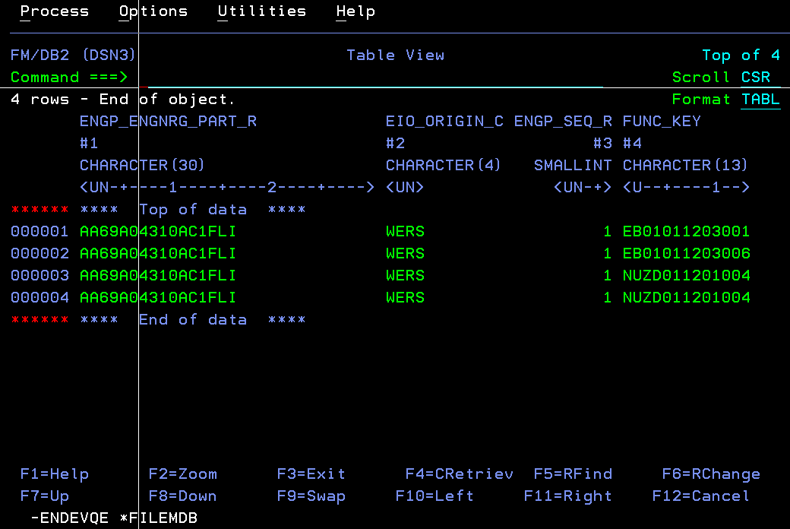

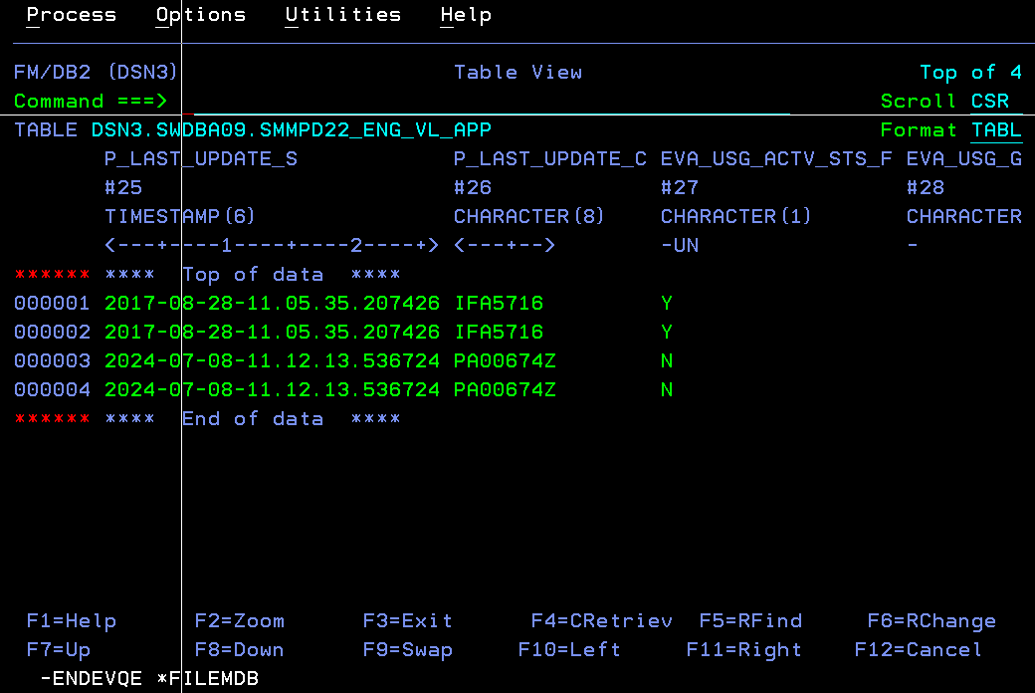

# Test Case-3 SMMPPRFA: Rationalization/De-rationalization is restricted

Initial Screen:

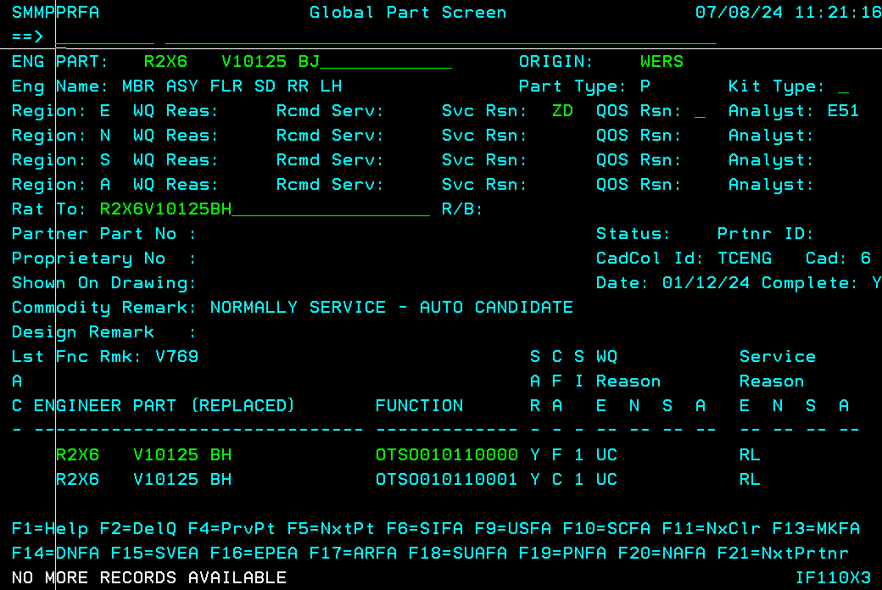

User trying to change rationalization info:

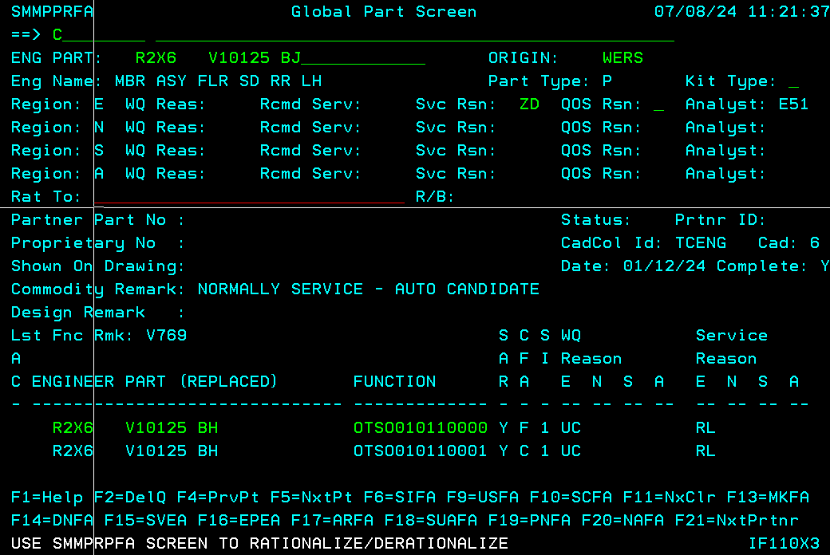

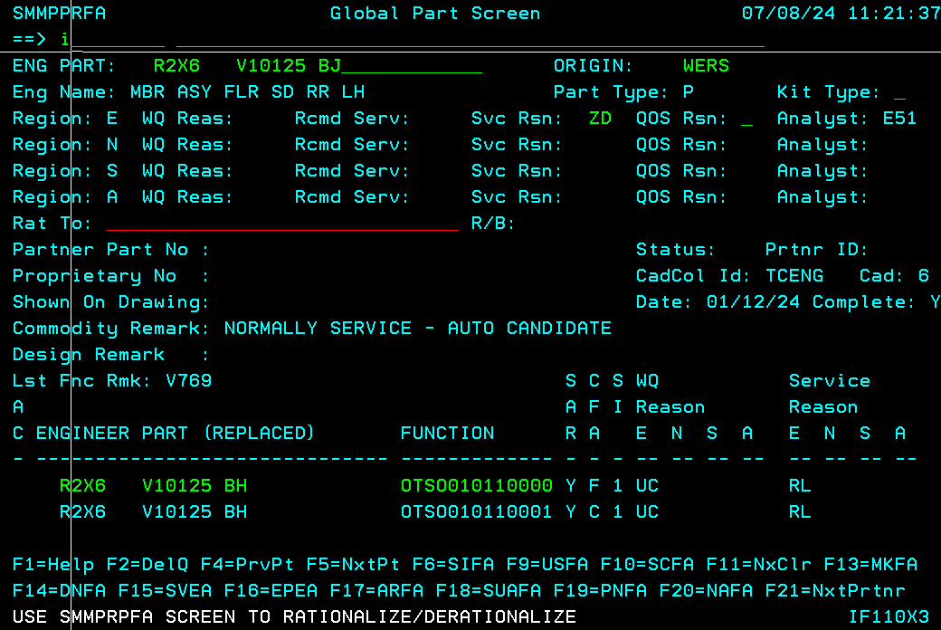

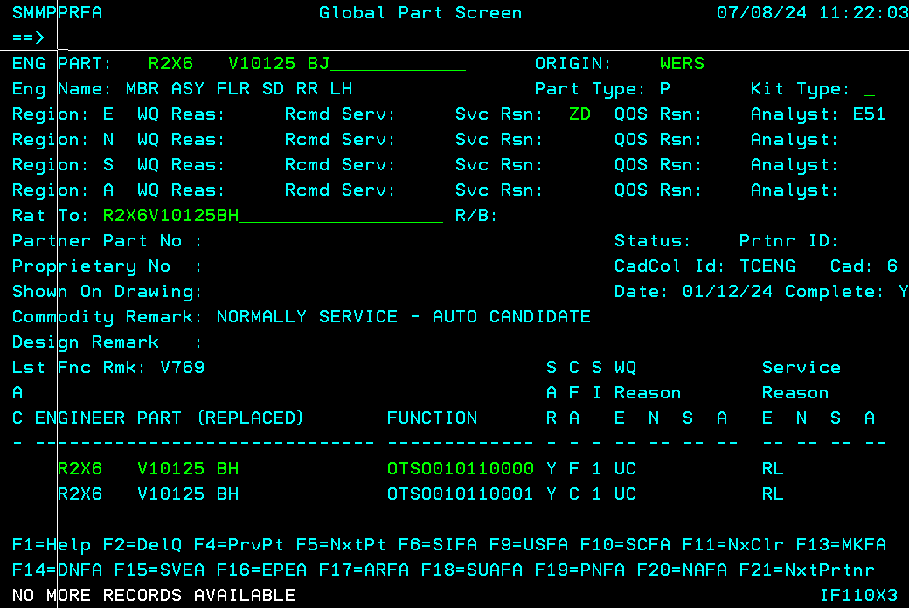

# Test Case-4 SMMPRPFA: Error message displayed when ‘To part’ service reason is not ‘RL’

‘Rationalized to’ part service reason not RL, its NN:

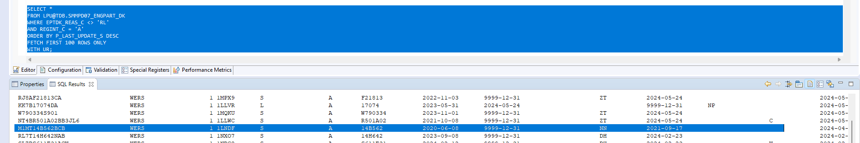

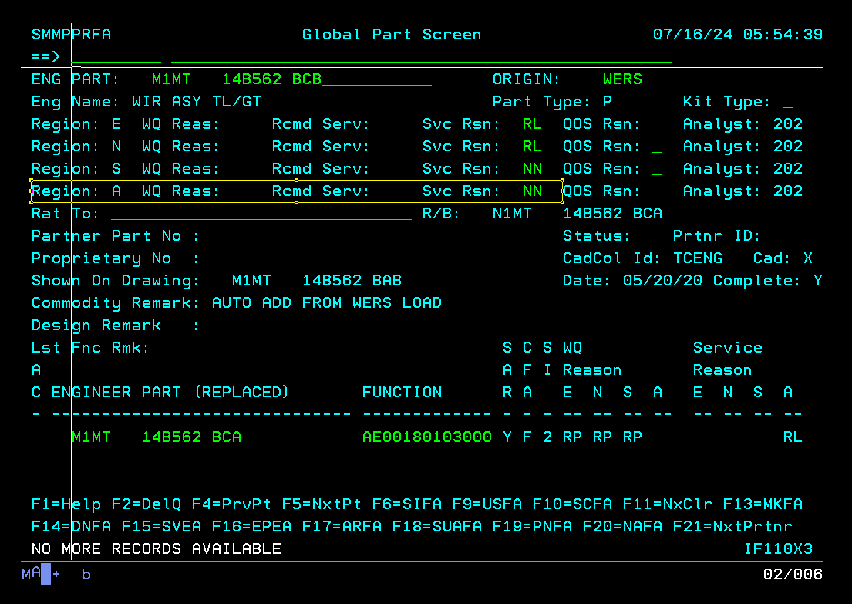

Trying the rationalization process now,

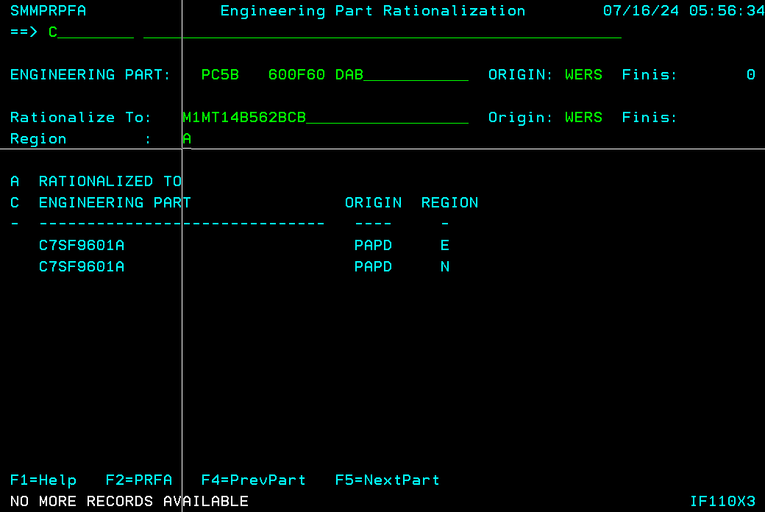

Press Enter:

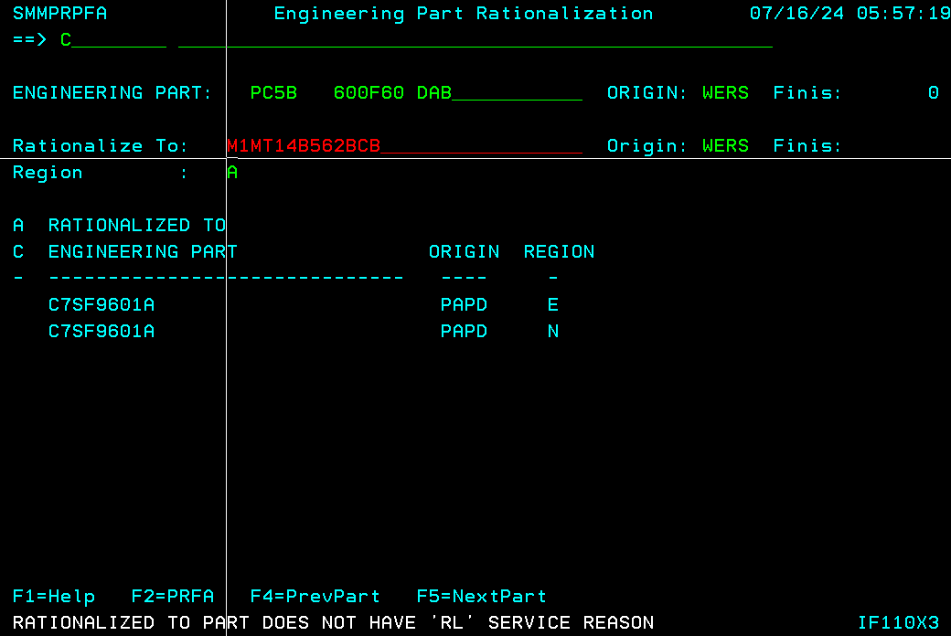

# Test Case-5 SMMPRPFA: Error message displayed when ‘From part’ not in D07/Disabled for region

From part disabled for **E region**/not in D07:

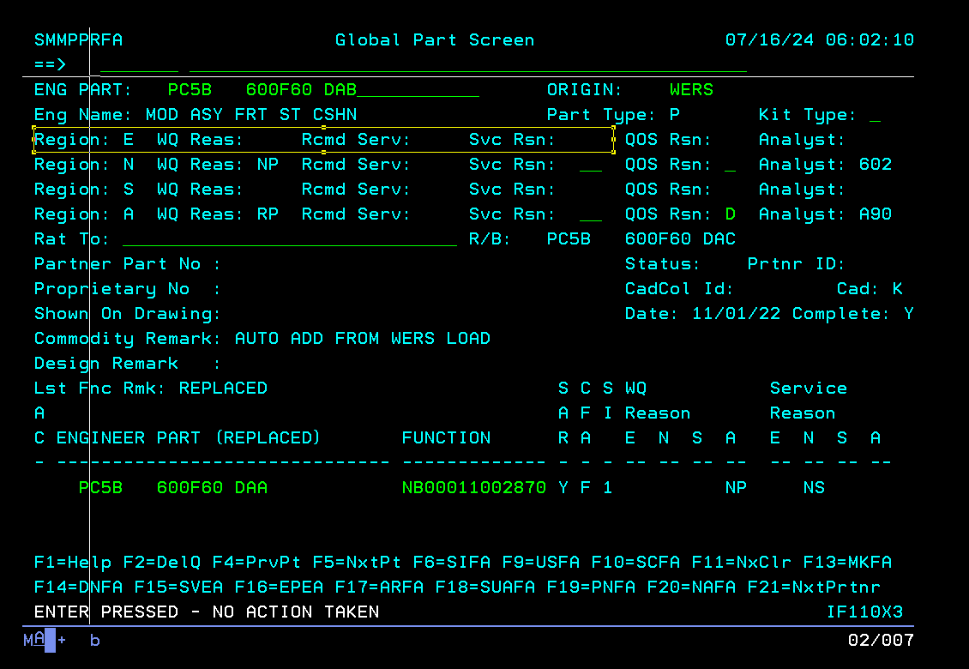

D07 table values: (no row for **E region**)

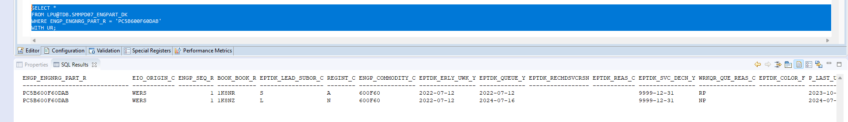

Trying to rationalize for E region:

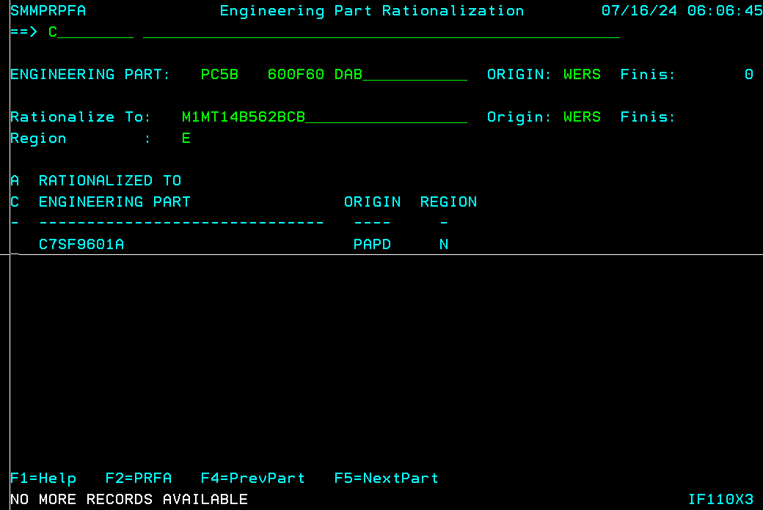

Error message is displayed

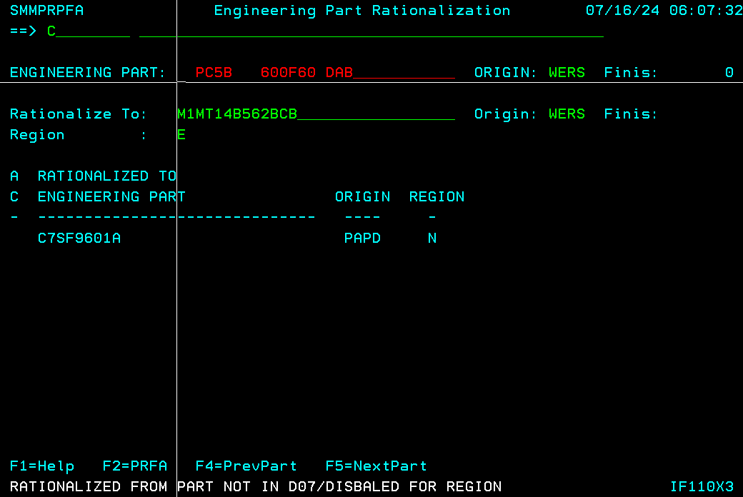

# Test Case-6 SMMPRPFA: Error message displayed when ‘To part’ origin is not entered/spaces.

Initial screen:

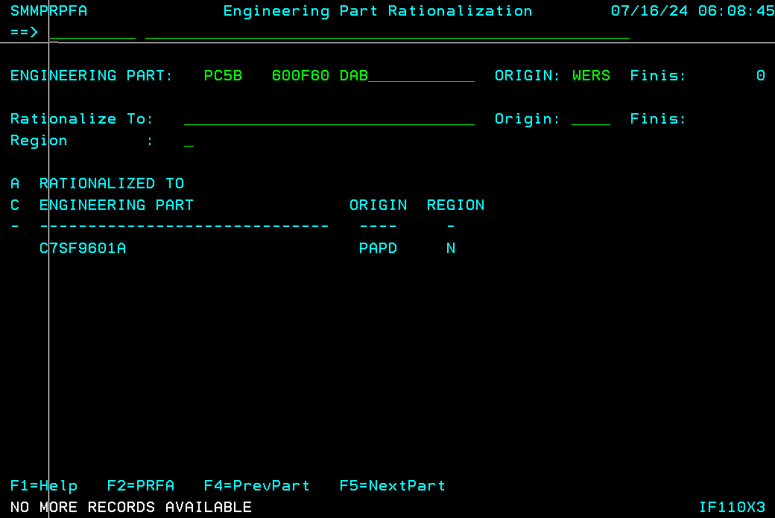Rationalization origin is not entered: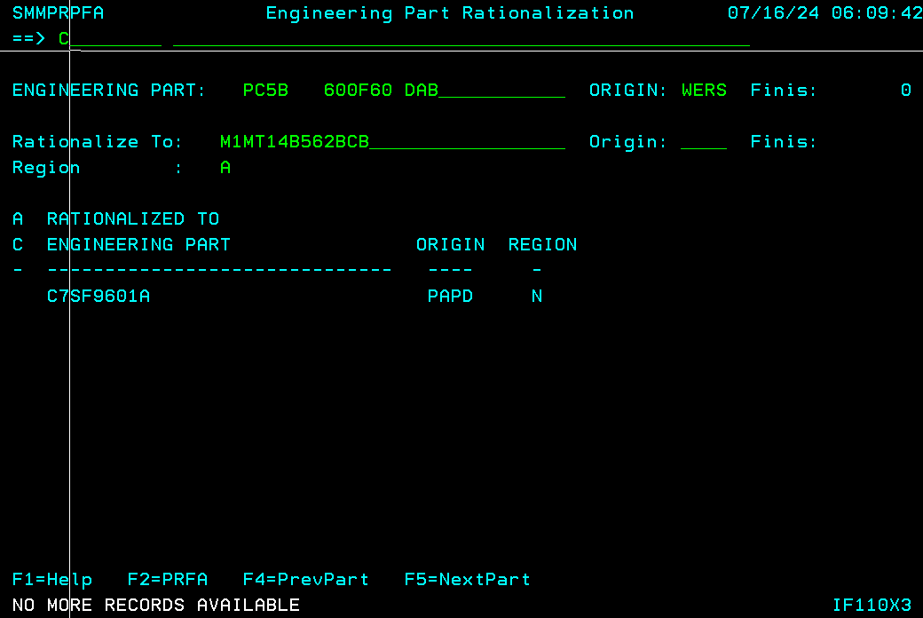

Enter is pressed:

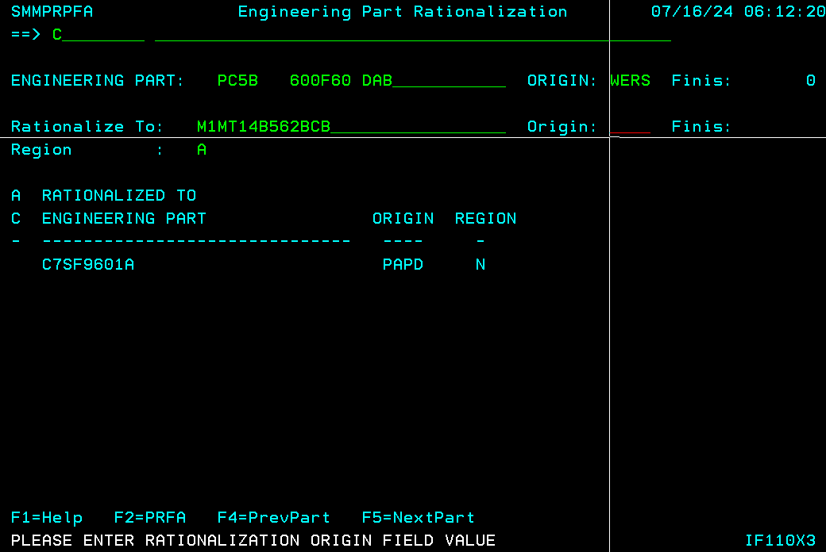

# Test Case-7 SMMPRPFA: From part reason code updated to ZD for rationalized region

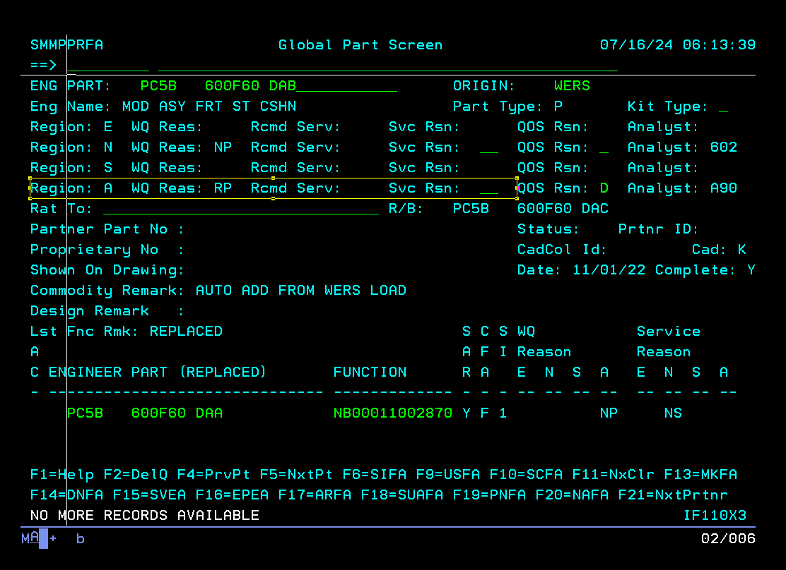A region service reason is not ZD:

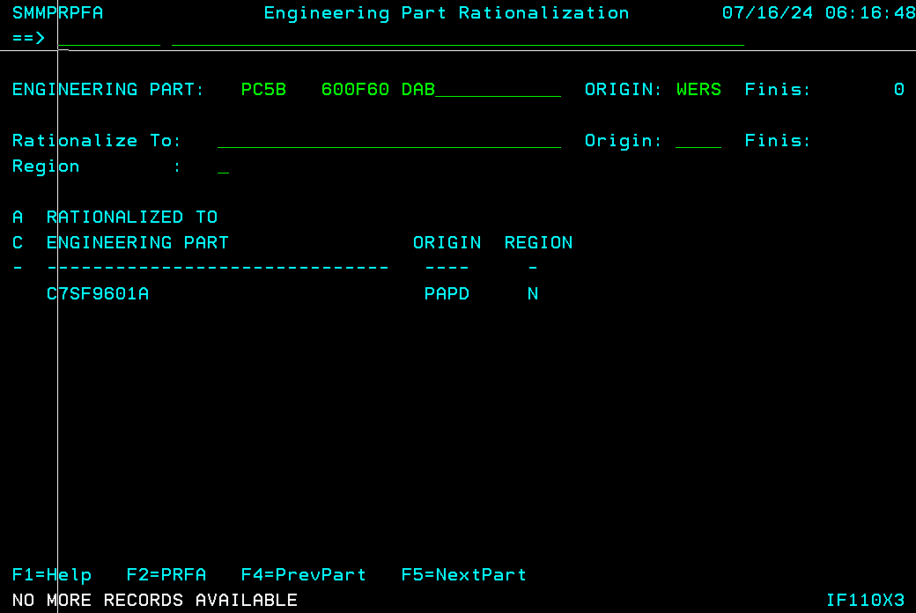

Finding a ‘to part’ to rationalize with ‘RL’ reason code

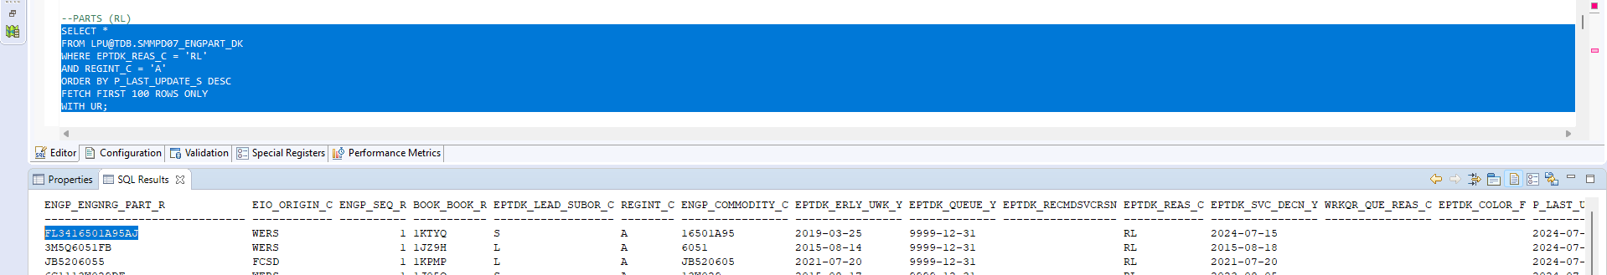

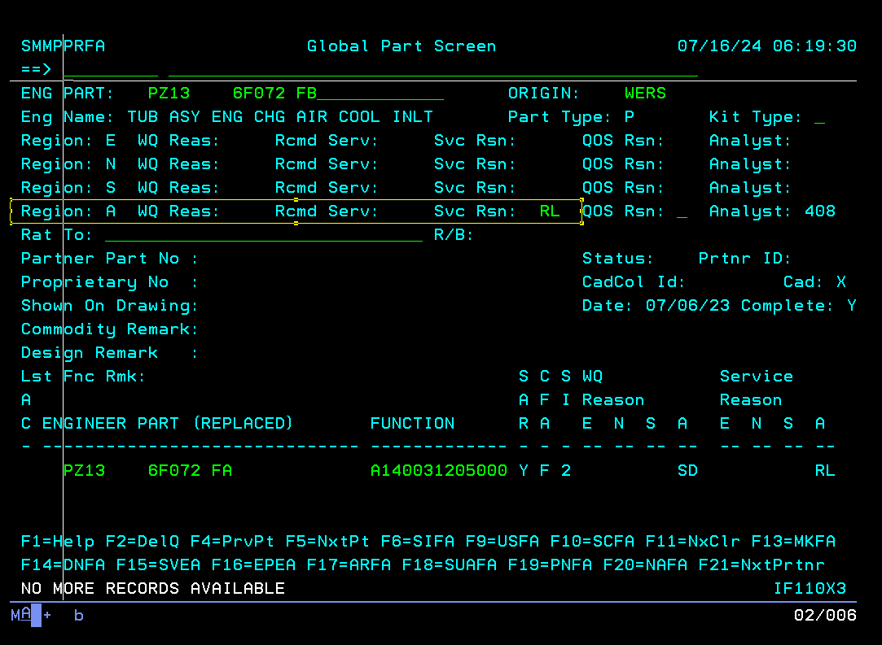

Trying to rationalize now:

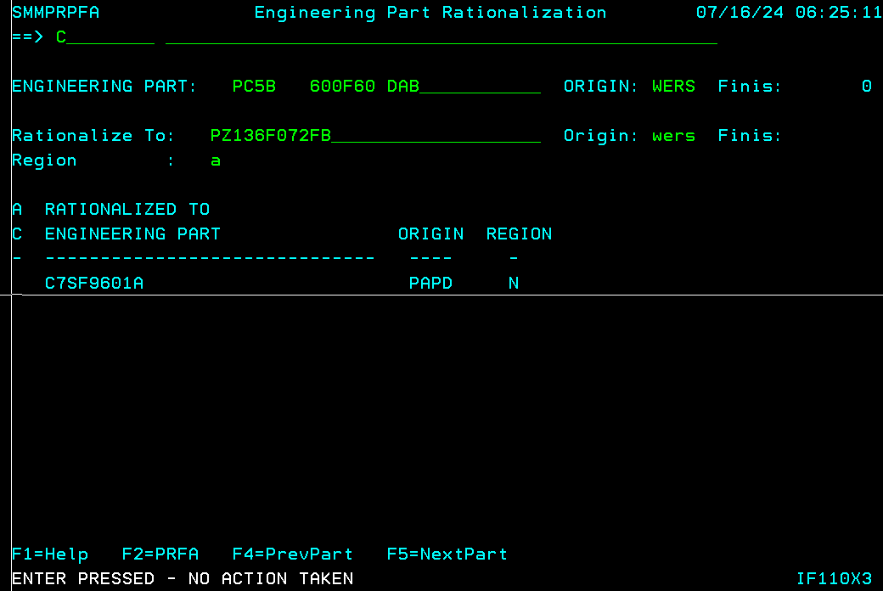

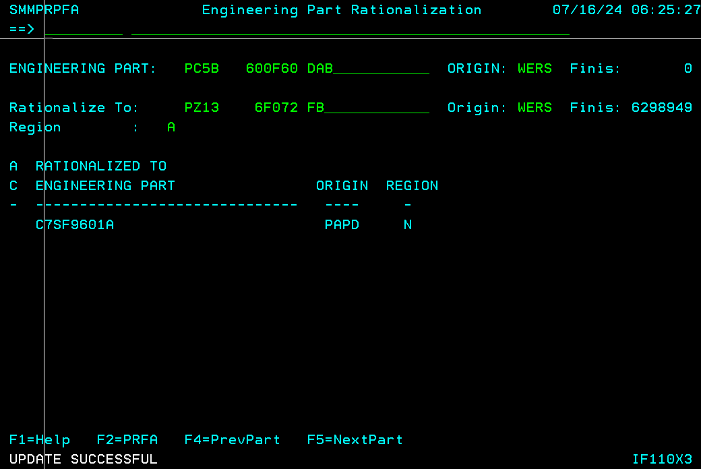

Inquiry:

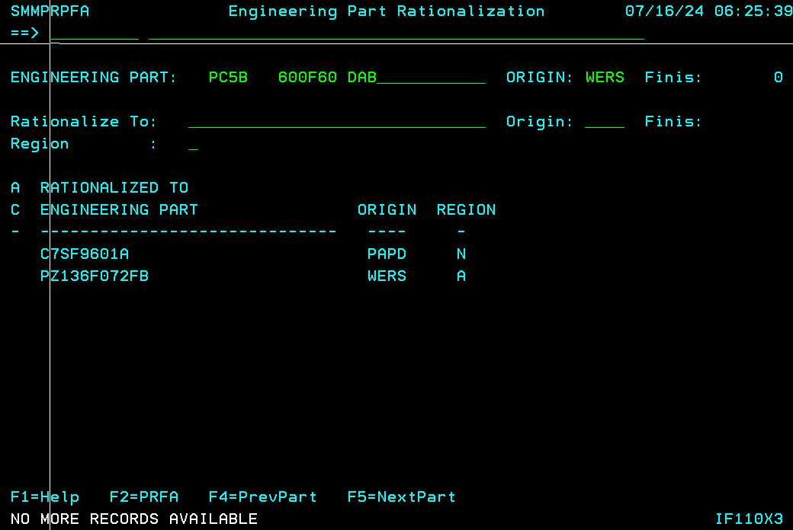

Service reason updated to ZD: